## PROGRAM DEFINITION

|  |
| --- |
|  |
| * A program to print a report for a list of Proforma Invoices that have or have not yet been invoiced |

## RELATED TABLES

|  |  |
| --- | --- |
|  | **Access** |
| * - | * - |

## ROLES

|  |  |
| --- | --- |
|  | **Test** |
| * User that has access to program |  |

## INITIAL PROCESS

|  |  |
| --- | --- |
|  | **Test** |
| * Set VAR_COMPANY_ID = Login User’s Company ID * Set VAR_USER_ID = Login User ID * Set VAR_LANGUAGE_ID = Login User’s Language ID * Execute this stored procedure, save the results to VAR_YEAR_RANGE   EXEC RSP_GS_GET_PERIOD_YEAR_RANGE  VAR_COMPANY_ID  , ''  , ''   * Set VAR_LOOKUP_SUPPLIER_LIST_GET_RECORD = Value from lookup PML00600 with the following parameters: * VAR_COMPANY_ID * Selected Property ID * ‘01’ * VAR_USER_ID * Set VAR_LOOKUP_JOURNAL_GROUP_LIST_GET_RECORD = Value from lookup GSL00400 with the following parameters: * VAR_COMPANY_ID * Selected Property ID * ‘10’ * VAR_USER_ID * Set VAR_LOOKUP_DEPARTMENT_LIST_GET_RECORD = Value from lookup GSL00700 with the following parameters: * VAR_COMPANY_ID * VAR_USER_ID * ‘’ * - |  |

## MAIN FORM

### USER INTERFACE

#### INITIAL VERSION

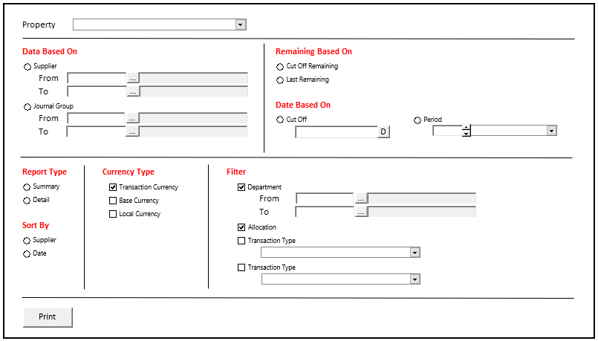

### BUTTON DEFINITION

|  |  |
| --- | --- |
| **Button Name** | **Action** |
| Print | Run PRINT REPORT PROCESS |

### DISPLAY PROCESS

#### FIELD DEFINITION

|  |  |  |  |
| --- | --- | --- | --- |
| **Name** | **Field** | **Type** | **Validation** |
| Property |  | Combo box  Set VAR_PROPERTY_LIST with  EXEC RSP_GS_GET_PROPERTY_LIST  VAR_COMPANY_ID  , VAR_USER_ID  Set property id = CPROPERTY_ID  Set property name = CPROPERTY_NAME  Set default selected property id = top 1 property id from VAR_PROPERTY_LIST.  Show name from the specific property id | * Mandatory * - |
| Data Based On |  | Radio button  Radio Value   * ‘1’ = SUPPLIER * ‘2’ = Journal Group   Set default value to SUPPLIER | * Mandatory * If selected value = SUPPLIER, then: * Enable Data Based On [SUPPLIER [From [Code]]] * Enable Data Based On [SUPPLIER [From [Lookup]]] * Enable Data Based On [SUPPLIER [To [Code]]] * Enable Data Based On [SUPPLIER [To [Lookup]]] * Else if selected value = Journal Group, then: * Enable Data Based On [Journal Group [From [Code]]] * Enable Data Based On [Journal Group [From [Lookup]]] * Enable Data Based On [Journal Group [To [Code]]] * Enable Data Based On [Journal Group [To [Lookup]]] * - |
| Data Based On [SUPPLIER [From [Code]]] |  | Text box | * Mandatory, if Data Based On = ‘1’ * After being changed, then check its name based on VAR_LOOKUP_SUPPLIER_LIST_GET_RECORD and save it to VAR_SUPPLIER_NAME. Finally: * If VAR_SUPPLIER_NAME is empty, then: * Display message “SUPPLIER [INPUT SUPPLIER Code] not found!”, [OK] * Set focus to Data Based On [SUPPLIER [From [Code]]] field * Else, set Data Based On [SUPPLIER [From [Name]]]’s value = VAR_SUPPLIER_NAME * - |
| Data Based On [SUPPLIER [From [Lookup]]] |  | Lookup | * Enter lookup program PML00600 with parameters: * VAR_COMPANY_ID * Selected Property ID * “01” * VAR_USER_ID   Then save the result to VAR_SUPPLIER_RESULT   * If VAR_SUPPLIER_RESULT is empty, then: * Display message “SUPPLIER [INPUT SUPPLIER Code] not found!”, [OK] * Set focus to Data Based On [SUPPLIER [From [Code]]] field * Else if VAR_SUPPLIER_RESULT exists, then: * Set Data Based On [SUPPLIER [From [Code]]] = CTENANT_ID * Set Data Based On [SUPPLIER [From [Name]]] = CTENANT_NAME * - |
| Data Based On [SUPPLIER [From [Name]]] |  | Text box | * Disabled * - |
| Data Based On [SUPPLIER [To [Code]]] |  | Text box | * Mandatory, if Data Based On = ‘1’ * After being changed, then check its name based on VAR_LOOKUP_SUPPLIER_LIST_GET_RECORD and save it to VAR_SUPPLIER_NAME. Finally: * If VAR_SUPPLIER_NAME is empty, then: * Display message “SUPPLIER [INPUT SUPPLIER Code] not found!”, [OK] * Set focus to Data Based On [SUPPLIER [To [Code]]] field * Else, set Data Based On [SUPPLIER [To [Name]]]’s value = VAR_SUPPLIER_NAME * - |
| Data Based On [SUPPLIER [To [Lookup]]] |  | Lookup | * Enter lookup program PML00600 with parameters: * VAR_COMPANY_ID * Selected Property ID * “01” * VAR_USER_ID   Then save the result to VAR_SUPPLIER_RESULT   * If VAR_SUPPLIER_RESULT is empty, then: * Display message “SUPPLIER [INPUT SUPPLIER Code] not found!”, [OK] * Set focus to Data Based On [SUPPLIER [To [Code]]] field * Else if VAR_SUPPLIER_RESULT exists, then: * Set Data Based On [SUPPLIER [To [Code]]] = CTENANT_ID * Set Data Based On [SUPPLIER [To [Name]]] = CTENANT_NAME * - |
| Data Based On [SUPPLIER [To [Name]]] |  | Text box | * Disabled * - |
| Data Based On [Journal Group [From [Code]]] |  | Text box | * Mandatory, if Data Based On = ‘2’ * After being changed, then check its name based on VAR_LOOKUP_JOURNAL_GROUP_LIST_GET_RECORD and save it to VAR_JOURNAL_GROUP_NAME. Finally: * If VAR_JOURNAL_GROUP_NAME is empty, then: * Display message “Journal Group [INPUT Journal Group Code] not found!”, [OK] * Set focus to Data Based On [Journal Group [From [Code]]] field * Else, set Data Based On [Journal Group [From [Name]]]’s value = VAR_JOURNAL_GROUP_NAME * - |
| Data Based On [Journal Group [From [Lookup]]] |  | Lookup | * Enter lookup program GSL00400 with parameters: * VAR_COMPANY_ID * Selected Property ID * “10” * VAR_USER_ID   Then save the result to VAR_JOURNAL_GROUP_RESULT   * If VAR_JOURNAL_GROUP_RESULT is empty, then: * Display message “Journal Group [INPUT Journal Group Code] not found!”, [OK] * Set focus to Data Based On [Journal Group [From [Code]]] field * Else if VAR_JOURNAL_GROUP_RESULT exists, then: * Set Data Based On [Journal Group [From [Code]]] = CJRNGRP_CODE * Set Data Based On [Journal Group [From [Name]]] = CJRNGRP_NAME * - |
| Data Based On [Journal Group [From [Name]]] |  | Text box | * Disabled * - |
| Data Based On [Journal Group [To [Code]]] |  | Text box | * Mandatory, if Data Based On = ‘2’ * After being changed, then check its name based on VAR_LOOKUP_JOURNAL_GROUP_LIST_GET_RECORD and save it to VAR_JOURNAL_GROUP_NAME. Finally: * If VAR_JOURNAL_GROUP_NAME is empty, then: * Display message “Journal Group [INPUT Journal Group Code] not found!”, [OK] * Set focus to Data Based On [Journal Group [To [Code]]] field * Else, set Data Based On [Journal Group [To [Name]]]’s value = VAR_JOURNAL_GROUP_NAME * - |
| Data Based On [Journal Group [To [Lookup]]] |  | Lookup | * Enter lookup program GSL00400 with parameters: * VAR_COMPANY_ID * Selected Property ID * “10” * VAR_USER_ID   Then save the result to VAR_JOURNAL_GROUP_RESULT   * If VAR_JOURNAL_GROUP_RESULT is empty, then: * Display message “Journal Group [INPUT Journal Group Code] not found!”, [OK] * Set focus to Data Based On [Journal Group [To [Code]]] field * Else if VAR_JOURNAL_GROUP_RESULT exists, then: * Set Data Based On [Journal Group [To [Code]]] = CJRNGRP_CODE * Set Data Based On [Journal Group [To [Name]]] = CJRNGRP_NAME * - |
| Data Based On [Journal Group [To [Name]]] |  | Text box | * Disabled * - |
| Remaining Based On |  | Radio button  Radio Value   * ‘1’ = Cut Off Remaining * ‘2’ = Last Remaining   Set default value to Cut Off Remaining | * Mandatory * If selected value = Cut Off Remaining, then: * Enable Date Based On * Set Date Based On = ‘1’ * Else if selected value = Last Remaining, then: * Disable Date Based On * Disable Date Based On [Cut Off] * Disable Date Based On [Period [Year]] * Disable Date Based On [Period [Month]] * - |
| Date Based On |  | Radio button  Radio Value   * ‘1’ = Cut Off * ‘2’ = Period   Set default value to Cut Off | * Mandatory * If selected value = Cut Off, then: * Enable Date Based On [Cut Off] * Disable Date Based On [Period [Year]] * Disable Date Based On [True] * Else if selected value = Last Remaining, then: * Disable Date Based On * Disable Date Based On [Cut Off] * Disable Date Based On [Period [Year]] * Disable Date Based On [Period [Month]] * - |
| Date Based On [Cut Off] |  | Date picker  Set default value:  SELECT dbo.RFN_GET_DB_TODAY (VAR_COMPANY_ID) | * Mandatory, if Date Based On = ‘1’ * - |
| Date Based On [Period [Year]] |  | Spinner  Spinner value:   * Minimum = VAR_YEAR_RANGE.IMIN_YEAR * Maximum = VAR_YEAR_RANGE.IMAX_YEAR   Set default spinner value:  SELECT YEAR(dbo.RFN_GET_DB_TODAY (VAR_COMPANY_ID)) | * Mandatory, if Date Based On = ‘2’ * - |
| Date based On [Period [Month]] |  | Combo box  Set VAR_PERIOD_MONTH_LIST (as array of object) with VAR_MONTH_NUMBER and VAR_MONTH_NAME.  Set VAR_MONTH_NUMBER = 01, 02, … , 12  Set VAR_MONTH_NAME = January, February, … , December  Set default combo box value month name based on  SELECT MONTH(dbo.RFN_GET_DB_TODAY (VAR_COMPANY_ID)) | * Mandatory, if Date Based On = ‘2’ * - |
| Report Type |  | Radio button  Radio Value   * ‘1’ = Summary * ‘2’ = Detail   Set default value to Summary | * Mandatory * - |
| Sort By |  | Radio button  Radio Value   * ‘1’ = SUPPLIER * ‘2’ = Date   Set default value to SUPPLIER | * Mandatory * - |
| Currency Type |  | Radio button  Radio Value   * ‘1’ = Base Currency * ‘2’ = Local Currency   Set default value to Base Currency  Note: There is one **disabled checked box** named “Transaction Currency”. It is a mandatory currency type for user to choose, but doesn’t need to be thrown as parameter (handled in Stored Procedure) | * Mandatory * - |
| Filter [Department] |  | Check box  Set:   * When True, then 1 * When False, then 0   Set default value to False | * Optional * - |
| Filter [Department [From [Code]]] |  | Text box | * Mandatory, if Filter [Department] = True * After being changed, then check its name based on VAR_LOOKUP_DEPARTMENT_LIST_GET_RECORD and save it to VAR_DEPARTMENT_NAME. Finally: * If VAR_DEPARTMENT_NAME is empty, then: * Display message “Department [INPUT Department Code] not found!”, [OK] * Set focus to Filter [Department [From [Code]]] field * Else, set Filter [Department [From [Name]]]’s value = VAR_DEPARTMENT_NAME * - |
| Filter [Department [From [Lookup]]] |  | Lookup | * Enter lookup program GSL00700 with parameters: * VAR_COMPANY_ID * VAR_USER_ID * “”   Then save the result to VAR_DEPARTMENT_RESULT   * If VAR_DEPARTMENT_RESULT is empty, then: * Display message “Department [INPUT Department Code] not found!”, [OK] * Set focus to Filter [Department [From [Code]]] field * Else if VAR_DEPARTMENT_RESULT exists, then: * Set Filter [Department [From [Code]]] = CDEPT_CODE * Set Filter [Department [From [Name]]] = CDEPT_NAME * - |
| Filter [Department [From [Name]]] |  | Text box | * Disabled * - |
| Filter [Department [To [Code]]] |  | Text box | * Mandatory, if Filter [Department] = True * After being changed, then check its name based on VAR_LOOKUP_DEPARTMENT_LIST_GET_RECORD and save it to VAR_DEPARTMENT_NAME. Finally: * If VAR_DEPARTMENT_NAME is empty, then: * Display message “Department [INPUT Department Code] not found!”, [OK] * Set focus to Filter [Department [To [Code]]] field * Else, set Filter [Department [To [Name]]]’s value = VAR_DEPARTMENT_NAME * - |
| Filter [Department [To [Lookup]]] |  | Lookup | * Enter lookup program GSL00700 with parameters: * VAR_COMPANY_ID * VAR_USER_ID * “”   Then save the result to VAR_DEPARTMENT_RESULT   * If VAR_DEPARTMENT_RESULT is empty, then: * Display message “Department [INPUT Department Code] not found!”, [OK] * Set focus to Filter [Department [To [Code]]] field * Else if VAR_DEPARTMENT_RESULT exists, then: * Set Filter [Department [To [Code]]] = CDEPT_CODE * Set Filter [Department [To [Name]]] = CDEPT_NAME * - |
| Filter [Department [To [Name]]] |  | Text box | * Disabled * - |
| Filter [Allocation] |  | Check box  Set:   * When True, then 1 * When False, then 0   Set default value to False | * Optional * - |
| Filter [Transaction Type] |  | Check box  Set:   * When True, then 1 * When False, then 0   Set default value to False | * Optional * - |
| Filter [Transaction Type [Name]] |  | Combo box  [THERE IS CURRENTLY NO AVAILABLE DATA // TABLE IS NOT EXISTS] | * Mandatory, if Filter [Transaction Type] = True |
| Filter [SUPPLIER Category] |  | Check box  Set:   * When True, then 1 * When False, then 0   Set default value to False | * Optional * - |
| Filter [SUPPLIER Category [Name]] |  | Combo box  Set VAR_PROFORMA_INVOICE_STATUS_LIST (as array of object) with values from:  SELECT _BS_CUST_TYPE.CCODE, _BS_CUST_TYPE.CDESCRIPTION FROM  RFT_GET_GSB_CODE_INFO('BIMASAKTI', VAR_COMPANY_ID, '_BS_CUST_TYPE', '', VAR_LANGUAGE_ID) _BS_CUST_TYPE  Set default combo box value of CDESCRIPTION based on the first array | * Mandatory, if Filter [SUPPLIER Category] = True * - |

### PRINT REPORT PROCESS

#### REPORT LAYOUT

PAPER SIZE: A4 LANDSCAPE

FONT SIZE: 7

REPORT TYPE: SUMMARY

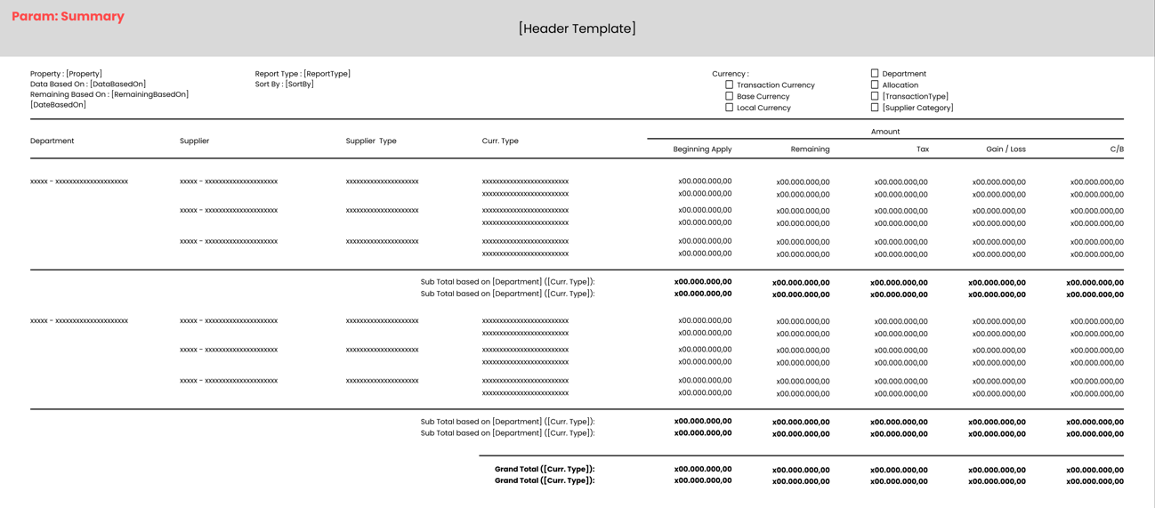

PAPER SIZE: A4 LANDSCAPE

FONT SIZE: 7

REPORT TYPE: DETAIL

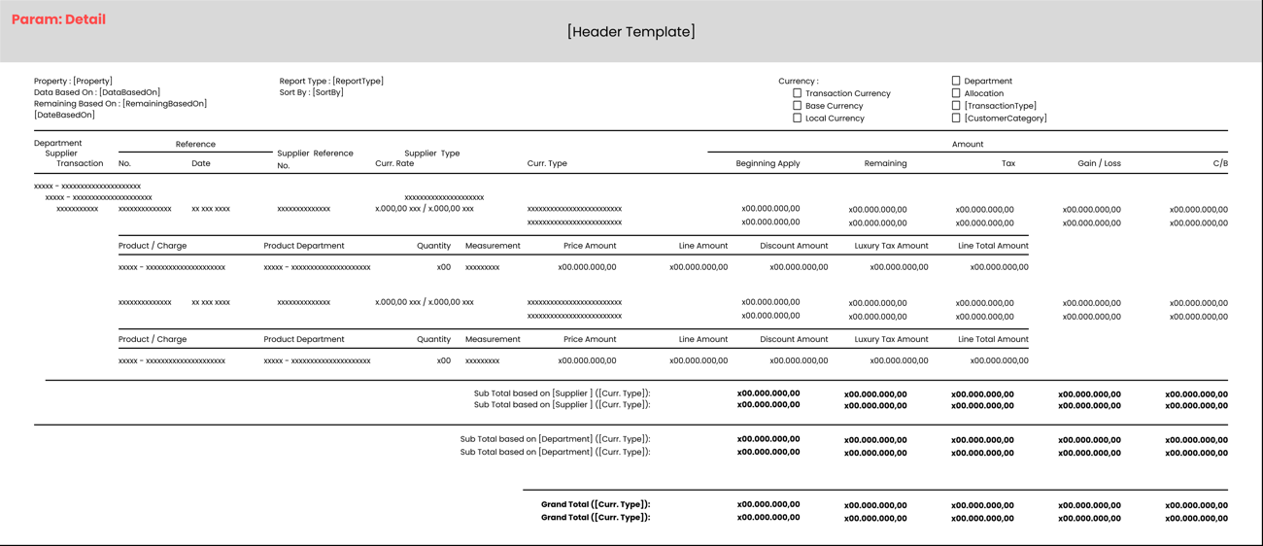

#### REPORT DEFINITION

REPORT SECTION FOR HEADER (IN GENERAL)

|  |  |  |  |
| --- | --- | --- | --- |
| **Section** | **Name** | **Field** | **Validation** |
| HEADER | Property | Selected Property | Show Property ID – Property Name  Ex. “ABCDE – Global Property” |
| Data Based On | Selected Data Based On | If Data Based On = ‘1’, then show “SUPPLIER”  Else if Data Based On = ‘2’, show “Journal Group” |
| Remaining Based On | Selected Remaining Based On | If Remaining Based On = ‘1’, then show “Cut Off Remaining”  Else if Remaining Based On = ‘2’, then show “Last Remaining” |
|  | Date Based On |  | If Remaining Based On = ‘1’, then:   * Show “Date Based On : ” * Followed with Date Based On * If Date Based On = ‘1’, then show “Cut Off” concatenated with “(Date Based On [Cut Off])” with culture date format. If there is no culture date format, use “d MMM yyyy”   Ex. “Date Based On : Cut Off (14 Sep 2001)”   * If Date Based On = ‘2’, then show “Period” concatenated with “(Date Based On [Period [Year]] Date Based On [Period [Month]])” with culture date format. If there is no culture date format, use “MMM yyyy”   Ex. “Date Based On : Period (Sep 2001)”   * -   Else if Remaining Based On = ‘2’, then suppress this label |
|  | Report Type |  | If Report Type = ‘1’, then show “Summary”  Else if Report Type = ‘2’, show “Detail” |
|  | Sort By |  | If Sort By = ‘1’, then show “SUPPLIER”  Else if Sort By = ‘2’, show “Date” |
|  | Transaction Currency |  | Always checked |
|  | Base Currency |  | If Currency Type = ‘1’, then show checked box  Else, show unchecked box |
|  | Local Currency |  | If Currency Type = ‘2’, then show checked box  Else, show unchecked box |
|  | Department |  | If Filter [Department] = 1, then show checked box  Else, show unchecked box |
|  | Allocation |  | If Filter [Allocation] = 1, then show checked box  Else, show unchecked box |
|  | Transaction Type |  | If Filter [Transaction Type] = 1, then:   * Show checked box * Followed with “Transaction Type : ” * Concatenated with selected transaction type   Ex. “Transaction Type : xxxxx”  Else, show unchecked box followed with “Transaction Type” |
|  | SUPPLIER Category |  | If Filter [SUPPLIER Category] = 1, then:   * Show checked box * Followed with “SUPPLIER Category : ” * Concatenated with selected SUPPLIER category   Ex. “SUPPLIER Category : xxxxx”  Else, show unchecked box followed with “SUPPLIER Category” |

REPORT SECTION FOR SUMMARY

|  |  |  |  |
| --- | --- | --- | --- |
| **Section** | **Name** | **Field** | **Validation** |
| REPORT GROUP | Department | CDEPT_CODE |  |
| Supplier | CSUPPLIER_ID |  |
| GROUP BY DEPARTMENT [HEADER] | Department | CDEPT_CODE - CDEPT_NAME |  |
| GROUP BY SUPPLIER [HEADER] | Supplier | CSUPPLIER_ID - CSUPPLIER_NAME |  |
| DETAIL | Curr. Type | CCURRENCY_TYPE_NAME - CCURRENCY_CODE |  |
| Beginning Apply Amount | NBEGINNING_APPLY_AMOUNT |  |
| Remaining Amount | NREMAINING_AMOUNT |  |
| Tax Amount | NTAX_AMOUNT |  |
| Gain / Loss Amount | NGAINLOSS_AMOUNT |  |
| C/B Amount | NCASHBANK_AMOUNT |  |
| GROUP BY SUPPLIER [FOOTER] | - | - | Suppress |
| DATA SUB TOTAL DEPARTMENT [HEADER] | - | - | Suppress |
| DATA SUB TOTAL DEPARTMENT [DETAIL] | Sub Total of Beginning Apply Amount | - | For this Section, use a Data Transfer Object, named VAR_DTO_SUB_TOTAL_DEPARTMENT with the following groups:   * CDEPT_CODE * CCURRENCY_TYPE_CODE   One SUPPLIER might have multiple Currency Type, so the Sub Total should be separated between each Currency Type |
| Sub Total of Remaining Amount | - | - |
| Sub Total of Tax Amount | - | - |
| Sub Total of Gain / Loss Amount | - | - |
| Sub Total of C/B Amount | - | - |
| DATA SUB TOTAL DEPARTMENT [FOOTER] | - | - | Suppress |
| GROUP BY DEPARTMENT [FOOTER] | - | - | Suppress |
| DATA GRAND TOTAL [HEADER] | - | - | Suppress |
| DATA GRAND TOTAL [DETAIL] | Grand Total of Beginning Apply Amount | - | For this Section, use a Data Transfer Object, named VAR_DTO_GRAND_TOTAL with the following groups:   * CCURRENCY_TYPE_CODE   One SUPPLIER might have multiple Currency Type, so the Grand Total should be separated between each Currency Type |
| Grand Total of Remaining Amount | - | - |
| Grand Total of Tax Amount | - | - |
| Grand Total of Gain / Loss Amount | - | - |
| Grand Total of C/B Amount | - | - |
| DATA GRAND TOTAL DEPARTMENT [FOOTER] | - | - | Suppress |
| FOOTER | - | - | Suppress |

REPORT SECTION FOR DETAIL

|  |  |  |  |
| --- | --- | --- | --- |
| **Section** | **Name** | **Field** | **Validation** |
| REPORT GROUP | Department | CDEPT_CODE |  |
| SUPPLIER | CSUPPLIER_ID |  |
| GROUP BY DEPARTMENT [HEADER] | Department | CDEPT_CODE - CDEPT_NAME |  |
| GROUP BY SUPPLIER [HEADER] | SUPPLIER | CSUPPLIER_ID - CSUPPLIER_NAME |  |
| SUPPLIER Type | CSUPPLIER_TYPE_NAME |  |
| DETAIL | Reference No. | CREF_NO |  |
| Reference Date | CREF_DATE |  |
| SUPPLIER Reference No. | CSUPPLIER_REF_NO |  |
| Curr. Rate | NCURRENCY_RATE & CCURRENCY_CODE |  |
| Curr. Type | CCURRENCY_TYPE_NAME |  |
| Beginning Apply Amount | NBEGINNING_APPLY_AMOUNT |  |
| Remaining Amount | NREMAINING_AMOUNT |  |
| Tax Amount | NTAX_AMOUNT |  |
| Gain / Loss Amount | NGAINLOSS_AMOUNT |  |
| C/B Amount | NCASHBANK_AMOUNT |  |
| DETAIL 2 | Product / Charge | CPRODUCT_OR_CHARGE_ID - CPRODUCT_OR_CHARGE_NAME |  |
| Product Department | CPRODUCT_DEPARTMENT_CODE - CPRODUCT_DEPARTMENT_NAME |  |
| Quantity | IPRODUCT_QUANTITY |  |
| Measurement | CPRODUCT_MEASUREMENT_NAME |  |
| Price Amount | NPRODUCT_PRICE_AMOUNT |  |
| Line Amount | NPRODUCT_LINE_AMOUNT |  |
| Discount Amount | NPRODUCT_DISCOUNT_AMOUNT |  |
| Luxury Tax Amount | NPRODUCT_LUXURY_TAX_AMOUNT |  |
| Line Total Amount | NPRODUCT_LINE_TOTAL_AMOUNT |  |
| DATA SUB TOTAL SUPPLIER [HEADER] | - | - | Suppress |
| DATA SUB TOTAL SUPPLIER [DETAIL] | Sub Total of Beginning Apply Amount | - | For this Section, use a Data Transfer Object, named VAR_DTO_SUB_TOTAL_SUPPLIER with the following groups:   * CDEPT_CODE * CSUPPLIER_ID * CCURRENCY_TYPE_CODE   One SUPPLIER might have multiple Currency Type, so the Sub Total should be separated between each Currency Type |
| Sub Total of Remaining Amount | - | - |
| Sub Total of Tax Amount | - | - |
| Sub Total of Gain / Loss Amount | - | - |
| Sub Total of C/B Amount | - | - |
| DATA SUB TOTAL SUPPLIER [FOOTER] | - | - | Suppress |
| GROUP BY SUPPLIER [FOOTER] | - | - | Suppress |
| DATA SUB TOTAL DEPARTMENT [HEADER] | - | - | Suppress |
| DATA SUB TOTAL DEPARTMENT [DETAIL] | Sub Total of Beginning Apply Amount | - | For this Section, use a Data Transfer Object, named VAR_DTO_SUB_TOTAL_DEPARTMENT with the following groups:   * CDEPT_CODE * CCURRENCY_TYPE_CODE   One SUPPLIER might have multiple Currency Type, so the Sub Total should be separated between each Currency Type |
| Sub Total of Remaining Amount | - | - |
| Sub Total of Tax Amount | - | - |
| Sub Total of Gain / Loss Amount | - | - |
| Sub Total of C/B Amount | - | - |
| DATA SUB TOTAL DEPARTMENT [FOOTER] | - | - | Suppress |
| GROUP BY DEPARTMENT [FOOTER] | - | - | Suppress |
| DATA GRAND TOTAL [HEADER] | - | - | Suppress |
| DATA GRAND TOTAL [DETAIL] | Grand Total of Beginning Apply Amount | - | For this Section, use a Data Transfer Object, named VAR_DTO_GRAND_TOTAL with the following groups:   * CCURRENCY_TYPE_CODE   One SUPPLIER might have multiple Currency Type, so the Grand Total should be separated between each Currency Type |
| Grand Total of Remaining Amount | - | - |
| Grand Total of Tax Amount | - | - |
| Grand Total of Gain / Loss Amount | - | - |
| Grand Total of C/B Amount | - | - |
| DATA GRAND TOTAL DEPARTMENT [FOOTER] | - | - | Suppress |
| FOOTER | - | - | Suppress |

#### VALIDATION

|  |  |  |
| --- | --- | --- |
| **Field** | **Condition** | **Validation Message** |
| Property | Empty | Please select Property |
| Data Based On | Data Based On = ‘1’ **AND** (Data Based On [SUPPLIER [From [Code]]] **OR** Data Based On [SUPPLIER [To [Code]]]) is empty | Please select SUPPLIER |
| Data Based On = ‘2’ **AND** (Data Based On [Journal Group [From [Code]]] **OR** Data Based On [Journal Group [To [Code]]]) is empty | Please select Journal Group |
| Date Based On | Remaining Based On = ‘1’ **AND** Date Based On = ‘1’ **AND** Date Based On [Cut Off] is empty | Please select Cut Off Date |
| Remaining Based On = ‘1’ **AND** Date Based On = ‘2’ **AND** (Date Based On [Period [Year]] **OR** Date Based On [Period [Month]]) is empty | Please select Period |
| Filter | Filter [Department] = 1 **AND** (Filter [Department [From [Code]]] **OR** Filter [Department [To [Code]]]) is empty | Please select Department |
| Filter [Transaction Type] = 1 **AND** Filter [Transaction Type [Name]] is empty | Please select Transaction Type |
| Filter [SUPPLIER Category] = 1 **AND** Filter [SUPPLIER Category] is empty | Please select SUPPLIER Category |

#### ACTION

|  |
| --- |
|  |
| * Execute this stored procedure:   RSP_PMR02000_GET_REPORT  VAR_COMPANY_ID  , selected Property ID  , selected Data Based On [SUPPLIER [From [Code]]]  , selected Data Based On [SUPPLIER [To [Code]]]  , selected Data Based On [Journal Group [From [Code]]]  , selected Data Based On [Journal Group [To [Code]]]  , selected Remaining Based On  , selected Cut Off  , selected Period  , selected Report Type  , selected Sort By  , selected Currency Type  , selected Filter [Department [From [Code]]]  , selected Filter [Department [To [Code]]]  , selected Filter [Allocation] flag  , selected Filter [Transaction Type [Code]] flag  , selected Filter [SUPPLIER Category [Code]] flag  , VAR_LANGUAGE_ID  Note for sending those parameters to execute the stored procedure above:   * If selected Data Based On = ‘1’, then: * Selected Data Based On [Journal Group [From [Code]]] = ‘’ * Selected Data Based On [Journal Group [To [Code]]] = ‘’   Else if selected Data Based On = ‘2’, then:   * Selected Data Based On [SUPPLIER [From [Code]]] = ‘’ * Selected Data Based On [SUPPLIER [To [Code]]] = ‘’ * If selected Date Based On = ‘1’, then: * Selected Period = ‘’   Else if selected Date Based On = ‘2’, then:   * Selected Cut Off = ‘’ * Value of Cut Off should be “yyyymmdd” * Value of Period should be “yyyymm” * If Filter [Department] = 0, then: * Selected Filter [Department [From [Code]]] = ‘’ * Selected Filter [Department [To [Code]]] = ‘’ * If Filter [Transaction Type] = 0, then selected Filter [Transaction Type] = ‘’ * If Filter [SUPPLIER Category] = 0, then selected Filter [SUPPLIER Category] = ‘’ * **!IMPORTANT!: DIFFERENT SELECTED REPORT TYPE RESULTING IN DIFFERENT OUTPUT** * Ex. 1 FOR SUMMARY [THERE IS CURRENTLY NO AVAILABLE DATA // TABLE IS NOT EXISTS]   EXEC RSP_PMR02000_GET_REPORT  ''  , ''  , ''  , ''  , ''  , ''  , ''  , ''  , ''  , '1'  , ''  , ''  , ''  , ''  , ''  , 0  , ''  , ''   * Ex. 2 FOR DETAIL [THERE IS CURRENTLY NO AVAILABLE DATA // TABLE IS NOT EXISTS]   EXEC RSP_PMR02000_GET_REPORT  ''  , ''  , ''  , ''  , ''  , ''  , ''  , ''  , ''  , '2'  , ''  , ''  , ''  , ''  , ''  , 0  , ''  , ''   * - |

# CR LIST

|  |  |  |
| --- | --- | --- |
| **CR** | **Description** | **Notes** |
|  |  |  |

#### TEMPLATE

#### VALIDATION

|  |  |  |
| --- | --- | --- |
| **Field** | **Condition** | **Validation Message** |
|  |  |  |
|  |  |  |

#### ACTION

|  |
| --- |
|  |
|  |